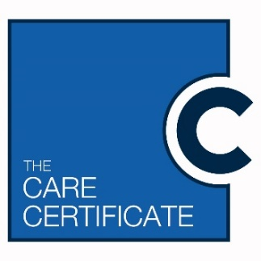



**Care Certificate**

**Portability:**

**Learning Connect**

**Care Certificate**

With consent, you can access the portfolio of evidence that accompanies this certificate

Find out more via: support@learningconnect.co.uk or 08006446899www.learningconnect.co.uk

**By awarding employer**

Signed by their representative

Name:

Role:

Signature:

**This is to certify that:**

**Is awarded this Care Certificate**

Based on the standards set by Health Education

England, Skills for Care and Skills for Health

Date of award:

**By signing this Certificate, the awarding employer and their representative confirm they:**

1. Have gone through their own quality assured process of checking the learner’s knowledge, skills and practice and they have made a judgement that the learner is competent on the date of award.
2. Have used Learning Connect’s online assessment system to as part of their process to check knowledge and they have gathered sufficient further evidence to make their judgement of competence through a variety of methods to include discussions, observations and feedback from the people being supported and their representatives.
3. Understand the Care Certificate is only the foundation and that they are responsible for supporting their employee to continue evaluating and developing an enhanced level of knowledge and skills that are personalised to meet the specific and individual needs of the people to whom they provide care and support to.